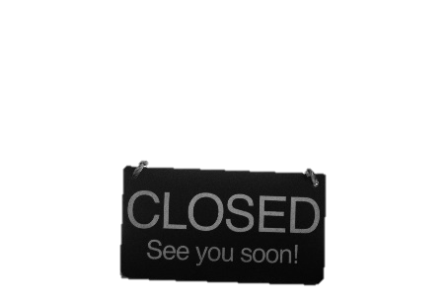

The staff miss the children greatly, but it has been wonderful to see you all engage in the online learning your teachers have prepared for you.

We will be staying in touch weekly also, so if you receive a call from a withheld number, it is most likely us! Please do answer, we’d love to keep in touch.

**Online House Points**

All of the staff at Jewell Academy would like to remind our learners that we are still continuing with the House System even though we are learning from home! Years 1 to 6 each have their own online House Point tracker sheet which you can see on your year group’s classwork page!

The House Point tracker sheet is completed by your teachers, so if you submit/complete work on Google Classroom, play TT Rockstars, Lexia and Prodigy (just to name a few of the apps) then you can earn yourself house points!

On the following Tuesday’s (31st March, 21st April and 28th April) will be the first Jewell Academy Maths House Event hosted on TT Rockstarrs. Mr Garrard has kindly organised a tournament style times table battle between the Houses. The battles will be open for learners to take part anytime between 9am and 3pm on the above dates!

**Free School Meals**

FSM are available to collect daily between 12 and 1pm. We understand that many of you are unable to collect your meals. Currently we are unable to offer delivery. We are waiting on government guidance as to how we can support this moving forward.

**Please note that over the Easter holidays (4th -19th April) NO FSM will be available at all as per normal school holidays.**

**Online Learning**

We can see that many of you have managed to access the online learning we have set up. Please email your teachers if you are having trouble accessing anything. The email addresses are: year*@jewell-aspirations.org

For example, year one would be: [year1@jewell-aspirations.org](mailto:year1@jewell-aspirations.org)

Please don’t forget to access Lexia, Google Classroom and TT Rockstars.

It has been the strangest start to my Principalship at Jewell! It has also certainly been one of the toughest times for friends, family and colleagues as we adjust to a new way of working and living in the fight against Coronavirus.

Firstly, I wanted to say a massive thank you to all of you who have kept your children safe at home and are following the government guidance. School is now closed to most pupils and we are operating a skeletal staff in order to provide care for the children of key workers.

I along with all of the staff wish you all well and hope to see you again very soon.