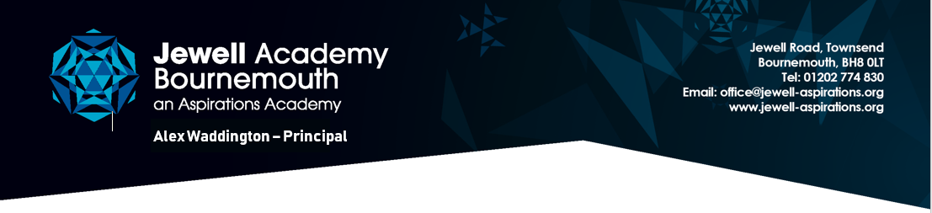
Friday 17th April 2020

Letter from Steve Kenning - Managing Director RE School Closure

Dear parents,

As we approach the end of the Easter holidays, I wanted to write to you to advise you about Jewell Academy’s position with regard to closure. You will be aware that the government plans to continue the current lockdown for the forthcoming few weeks. This means that for the foreseeable future all schools will continue to remain closed to all pupils with the exception of those of key workers and those who are classed as vulnerable. So please continue to keep your children at home unless they fall into one of these two categories. We will endeavour to continue to provide on-line education and ideas for home education. As a reminder, these resources can be found here:

Google Classroom
Tapestry (for Jellyfish and Reception children)
Lexia
TTRockstars
Spelling Shed
PIXL Apps

Those parents of children eligible for Free School Meals should have received government vouchers by now. If you have not, please contact the school office.

At the moment, the government has not provided any indication of when schools may reopen or how this will happen. We are in the process of planning for how this might be managed but will need to wait for clear guidance from the government regarding expectations of schools before we can finalise these plans and share them with you. However, rest assured that we will contact you as soon as this advice and guidance becomes clear.

I do hope that you and your family are managing as well as can be expected in these difficult times.

Steve Kenning
Managing Director
