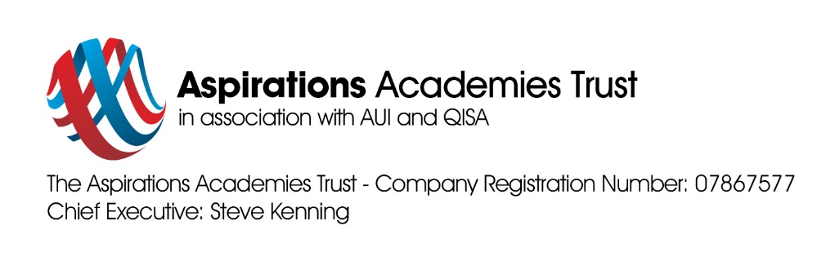

Dear Parents/Carers

We are delighted that you and your child has been offered a place and will be joining Reception here at Jewell Academy this coming September. On behalf of the staff, children and parents, it gives me great pleasure to welcome you and your family to our school.
As you are all very aware, the current climate is that of an unpredictable one. It is our main priority to ensure that you and your child have a smooth and successful transition to Jewell Academy.
Over the upcoming months, we shall be hosting several events either at school or if not possible online in order to support the transition of your child starting school, the dates and times of these will be shared with you in due course. We are currently working on creating effective and manageable ways to communicate as much information where possible to you all.
Please keep updated using our website: https://www.jewell-aspirations.org.
You will find all the relevant information under the Admissions section.
At Jewell we believe that our high expectations help ensure that all students, no matter what their starting points, can achieve and we will do everything possible to make this happen. We pride ourselves on our fantastic Early Years, which provides our children with fantastic facilities and opportunities.
We look forward to you joining our community and the start of your child’s seven year journey at Jewell Academy
Yours sincerely,
Mrs Taylor

Early Years Leader

